# **Web Project Website Information**

1. The purpose of this website is to show off my portfolio to future recruiters that can learn a bit about myself. They can also learn about the experience I might already have with coding which is a career choice of mines in the future. As well learn a bit more about myself personally such as where I was born, where I grew up, and my past high school and college experience I had. Hopefully this site also helps future students to get an idea on how to build their future portfolio website.
2. The main goal I would like my website to accomplish would be to get a future career in web development or software development for a popular company such as Google, Microsoft, Apple etc. The other goal would be to have a great impact on students when it comes to fitness goals and healthy lifestyle. I would have to talk about the different projects I have created in web development to get future recruiters interested in me. I myself have been into fitness for about 8 years and have real life videos and pictures of my progress which can be used for evidence to show that I have experience in the fitness industry.
3. My target audience for my portfolio website can be any gender and ages young as 13 years old. Fitness is a very big part of everyone life style and I truly believe that everyone should be a stronger and healthier version of themselves no matter what age, gender or race they are. Web development and coding in general is a very big industry that can get kids interested for their future career choices and hopefully they learn something off my coding experience.
4. The biggest opportunity my website introduces for people is to learn a bit about web development but mainly HTML, CSS, and Python coding. This will help individual that have no idea what coding is to get them to learn and understand a bit which can lead them to learn more. The other opportunity my website introduces is healthy lifestyle and show people that they can achieve anything in the fitness when it comes to losing weight, getting stronger, or just being a better version of themselves.
5. The type of content I would be using would be web developing projects I myself have created to show off the experience I have in coding. This will understand future recruiter to learn the skill level I have with coding itself. I would also use my own images/videos I have of myself in the gym to show real life examples of my journey in fitness to motivate people that I was in their position and they can achieve the same goals I have.
6. <http://laurabellingham.com/>

<https://garyvaynerchuk.com/veefriends/>

# **Web Project Site Map**

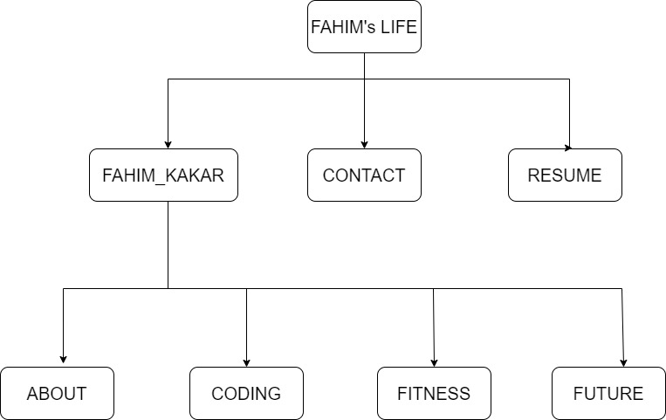

# **Web Project Layout Design**

